Project 2



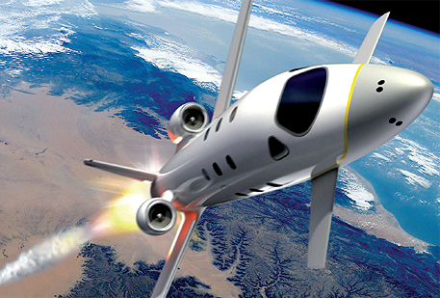

**FDIR**

*Spacecraft fault protection system*

**Euro Team**

|  |  |
| --- | --- |
| **Mikko AHVENNIEMI** | 20096680 |
| **Pierre ALAUZET** | 20096699 |
| **Julien COLIN** | 20096706 |
| **Benoît STARCK** | 20096705 |

**Table of contents**

December 12th, 2009

**CS554 - Design for Software & Systems**

Illustration table 3

Introduction 4

1. ACME, a powerful ADL 5

2. Utility tree 6

3. Architecture 7

4. Architectural approach analysis 8

5. Discussions & alternatives 9

Conclusion 10

References 11

Annexes 12

1. 12

**Illustration table**

Aucune entrée de table d'illustration n'a été trouvée.

**Introduction**

In the purpose of applying and studying real case project for the *Design for Softwares and Systems* course, our team is required to understand and design a fault protection system for a spacecraft as described in the article by Steve Easterbrook et al. [Eas98]. The **first part** of this global project was to understand the **problems** we have to respond to, to specify the**needs of our client**and to start thinking about a**user system interface**.

In this second report, the purpose will be to use the clear problem’s understanding we obtained thanks to the first part to specify a **global architecture** for the FDIR system. The first step of this job is to remind FDIR’s functional requirements and **quality attributes**, as identified and improvised during our analysis phase, and improved by the use of the **ATAM process** for architectural evaluation, that we had the chance to learnt during this course.

For constructing this architecture, we will use the **ACME architectural description language** that we presented during our OP5. This language allows us to describe a complete architecture using several architectural **styles** to draw it in a fashion manner using the ACME studio software.

First of all we are going to present several outputs of the **ATAM process** such as the **utility tree** presenting the system’s quality attributes, and several **scenarios** describing how our architectural decisions should meet the non functional requirements of our system.Then we will list the **systems** we want to describe as components of our system, we will discuss our choices on the architectural styles we want to use, while proposing several approaches to describe the overall system. We will then present our final architectural choice, how this choice match to our quality attributes. The final part will consists of a discussion about the **risks**, the non-risks, sensitivity points, and tradeoff point related to our finalized architecture. We will also provide some **alternatives** and **criticizes** about our work.

The materialpresented on this report is a synthesis of our previous work for OP4 and OP6, including some refactoring of our architectural diagrams and modifications based on the feedbacks we obtained from professor and TA.

1. **System description & business case**

1. **Utility tree**

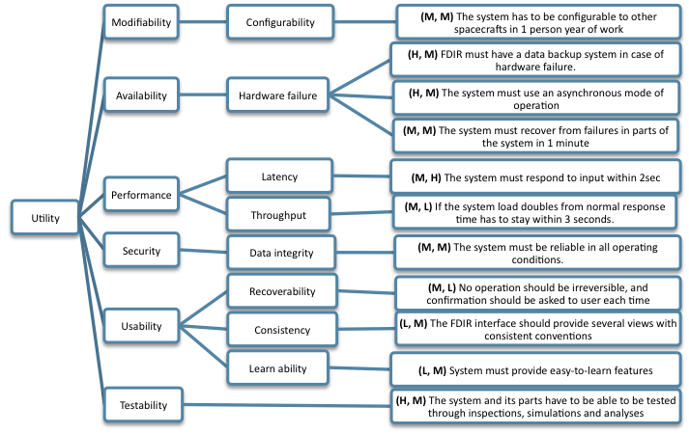

*Fig1. Utility tree*

- Use case scenarios

- No operation should be irreversible, and confirmation should be asked to user each time

-user action should be done at any moment

- The FDIR interface should provide several views with consistent conventions

- Growth scenarios

- A new sub-system must be able to be installed in to the FDIR in 1 person day of work

-Exploratory scenarios

- If the system load doubles from normal response time has to stay within 3 seconds.

-if a FDIR sub-system is crashing, FDIR should still work

- The system has to be configurable to other spacecrafts in 1 person year of work

1. **Architecture**
2. Overall architecture

Here is our first architecture:

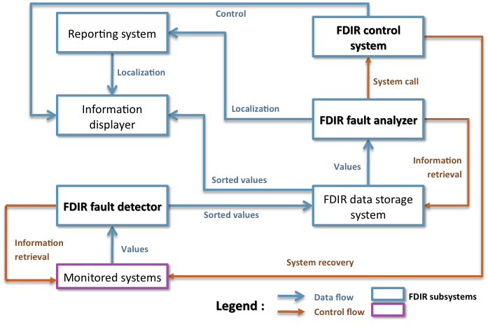

**Spacecraft systems**

*Fig2. Dataflow and Control flow architecture proposal*

This architectural proposal was our first thought for FDIR architecture. As FDIR system is composed of a lot of systems interacting with each other by sharing data and/or instructions, the idea appeared to describe it using a mix between data flow and control flow architectural styles. The different elements are the ones described in the text, and summarize here:

* The monitored systems which include every spacecraft’s systems whose values are treated by the FDIR.
* The fault detector which collect all these values, treat them and sort them before transferring it to the storage system.
* Stored values which display and check by the fault analyzer to determine fault localization. This system store each data of the entire system, like reports, all information displayed, all the bugs and information about these bugs, the conclusion of the fault analyzer concerning a problem, the current person who have the control at a moment,…
* Localization is sent to fault report maker system that display issues on the screen.
* The fault analyzer call the control system (can be either automatically or manual control).
* The control system is able to perform recovering actions on monitored systems.

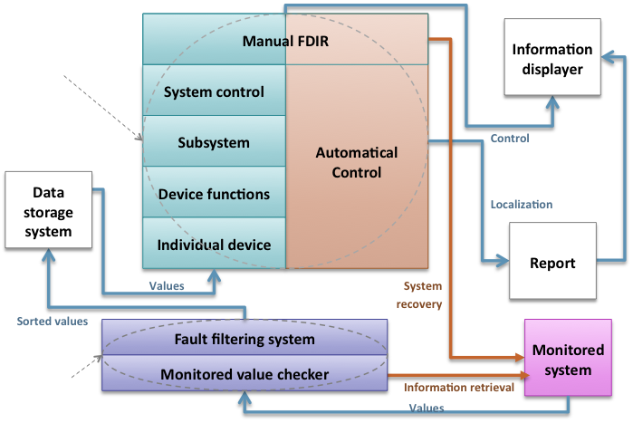

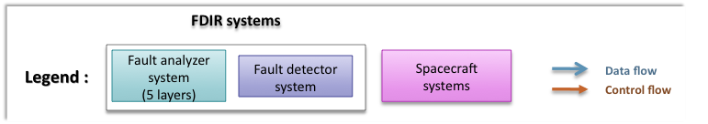

*Fig3. Dataflow and Control flow architecture proposal*

This architecture is our second proposal. In this description we also use data flow and control flow interactions, but we decided to describe several systems with a layered architecture. The previously saw FDIR fault detector is here describe as a two-layered system; the monitored value checker is collecting the data and is accessible to the fault filtering system that filters and sort the data. We also merged the fault analyzer and the control system in the same layered block. Four layers are taking care of fault analyzing, when one layer can’t resolve it the upper layer access to it and take care of the fault. Each of these 4 layers is interacting with the automatic control part. When none of these layers can resolve the problem, it goes to the manual layer that wraps the control part in order to provide manual control.

We notice that this architecture works with “events”. Indeed, it’s when a problem appears that this system will respond. When a component needs information, he will launch a procedure to get this information. And the most important, when a component react to information he got earlier, he‘ll send data after a treatment, but only at this time. If there is no problem for a little while, the most components will not react during this period. So that’s why we based our proposal to an event-based architecture.

The event-based architectures are mostly based on a famous architectural style: the publish subscribe style.

1. Publish subscribe description

Before building our system with this style, we’ll define it briefly to see the likeness with the functioning of our system.

Publish/subscribe (pub/sub) is an asynchronous messaging paradigm where senders, the publishers, post different messages on a server (an event service or event bus); then the subscribers pay or not to see the different posts. In fact, subscribers express several interests about few topics, and only receive messages that are of interest, without knowledge of who, or where, are the publishers. Users have to subscribe to an event if they are interested in receiving notifications of this topic. These notifications are generated by a publisher. User (the subscriber)is subscribing while publishers are notifying him about several news he asked for.When an event is created, it is generating some notifications from the publisher by a *publish()*function/method. An event service between publishers & subscriber allows the system to work under several abilities:

1. **Space decoupling**: publisher & subscriber work indirectly between them without knowing each other. In fact, the event service links the publisher to the subscriber in order to make it work.
2. **Time decoupling**: publisher can send notification while subscriber is disconnected. Vice & versa, user can see notification while publisher is not running.
3. **Synchronization decoupling**: concurrent activities can be performed by publishers & subscribers. They are asynchronously notified of an event.

The publish subscribe style can work in two different ways:

* **Topic-based P/S:** the topic-based P/S is strongly similar to “groups” notion. There are bundle communication peers, with methods to characterize & classify event content (divided by keys in a string shape).The first systems using P/S were based on group of communication. Difference between groups & topics is that groups are used for maintaining strong consistency between the replicas of a critical component in a local area network (LAN), whereas topics are used to model large-scale distributed interactions. Individual topics are linked to distinct communication channels. Hierarchies are orchestrating topics. Topics regroup event in content and structure. It is static & primitive but efficiently implemented.
* **Content-based P/S:** a content-based P/S corresponds to a subscription scheme based on the actual content of the considered events. The user specifies what he wants using filters. Participants can subscribe to logical combinations of elementary eventsand are only notified upon occurrence of the composite events. It is highly expressive but sophisticated protocols to put in place.

There are two types of architecture that you can use when you decide to use this style. The first one is a centralized architecture, that is to say that messages are sent to a single one entity which stores everything (reliability, consistency & transactional support). Message goes to the producer to the consumer passing by the entity. Centralized architecture is following this scheme:

producer🡪 entity 🡪 consumer

The second way is a distributed architecture: at the contrary, distributed architecture is asynchronous & anonymous. In this case, messages are going fasterand the delivery is even more efficient.Entity is not present anymore. That means that there is directed link and direct relations between the producer & consumer.

Producer🡨🡪 consumer

To conclude this presentation, we‘ll present now the main qualities of the pub sub style:

1. **Persistence:**

Message sent without generating replies. Transmission message is not controlled. Durability of information is really important, even more than guarantee in reliability. Has to check that message would not be lost.

Persistence is present in centralized architecture. Indeed, entity is checking and storing message till it is delivered. Nevertheless, it is not present in distributed architecture.

2. **Priorities:**

Priority is working with persistence. When messages have to be sent, priority can check whether there are some “real-time” events which need to be send before others. This affect messages in transit. It is actually a best effort QoS.

Priority aspect is present in both centralized and distributed architectures.

3. **Transactions:**

It is used to join a sequence of message into one block in order to send it in one time. Transaction is really useful when we encounter a failure. In this, none of the sequence is sent.

4. **Reliability:**

Reliability allows making sure that messages or sequences are delivered to the entities. It is really close to persistence aspect.

1. Choice, justification and application to the FDIR system

So, in the FDIR system, the different devices subscribe to sub-systems which in turn listen to events broadcasted by the devices. For our case, these events can be for example “announce value” event.

Moreover, the FDIR system looks like to a topic-based publish subscribe: indeed, the components are interested in a certain topic. For example, the report component just needs localization and a description of the failure to do a report.

We can also notice that the different component of the FDIR system communicate directly between each others to send or get some information. So it is a distributed architecture. We don’t have a central unit which forwards all the messages according the topic. The components ask directly the components that have the requested information.

Besides the publish subscribe style brings strong advantages:

* Enables asynchronous processing
* High potential for resilience in case of failure
* Load can be balanced efficiently between systems

So it’s corresponding well for the FDIR system and its goals. As you know, we chose to prioritized 3 qualities attributes: the availability, the reliability and the recoverability. So, the publish subscribe style answer all these needs. That’s why we choose it!

Besides, as we explained, we chose to prioritized two scenarios:

* User action should be done at any moment (Use case scenario)
* If a FDIR sub-system is crashing, FDIR should still work (exploratory scenario)

🡪So we’ll create our architecture based on these two scenarios.

1. The choice of Acme

In order to create our architecture, we had to choose an ADL (Architecture Description Language). An ADL is a language for modeling a software system’s conceptual architecture, distinguished from the system’s implementation. ADLs bring the tools for architecture evolution and reusability. There are different ADLs: Wright, Rapide, Unicon, Abacus…

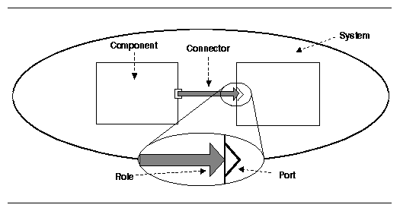But we decided to choose another ADL: ACME. We did this choice for several reasons. First of all, it is well know and developed in the same university as ATAM method – *Carneggie Melon University.* It provides a generic, extensible infrastructure for describing, representing, generating, and analyzing software architecture language description. Moreover it provides descriptions that are easy to understand for everyone. ACME describes a whole system thanks to a library of 7 architectural elements (components, connectors, ports, roles, systems, representations and representation maps), and manage several architectural families (Pipe & filters, Client & servers, Pub-Sub,..).

In addition, Acme provides a tool to build easily our architecture: AcmeStudio. AcmeStudio is very simple to use. It is based on an Eclipse interface, with a main view to draw the architecture, a group tabs with properties, and some tools to draw in another tab. We have to choose at the beginning which family of components we want to use in order to build our architecture, that’s all! Besides, the corresponding code is automatically generated when we draw the architecture.

That’s the main window of ACMEStudio.

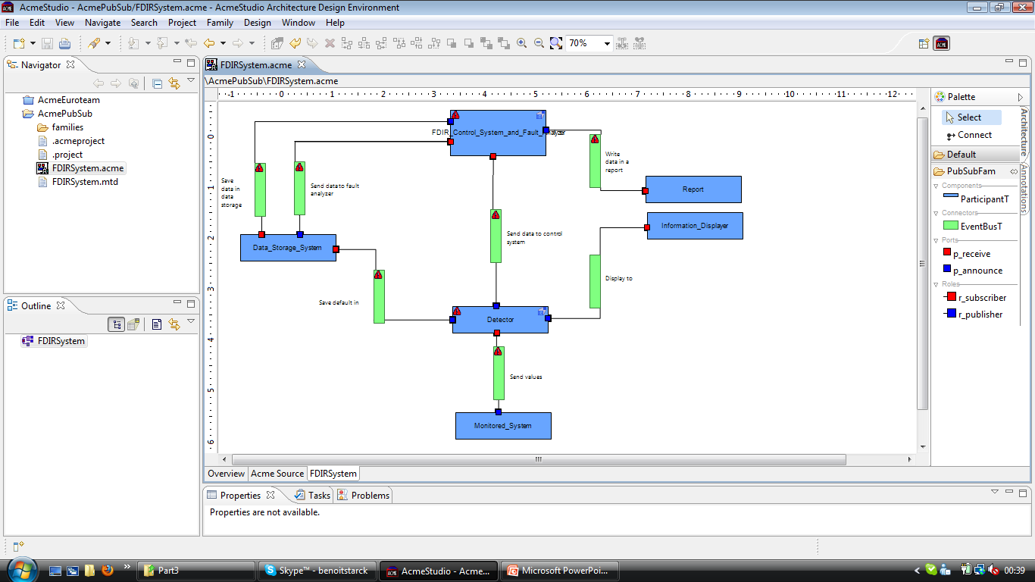

The next picture represents our FDIR architecture by using this tool.

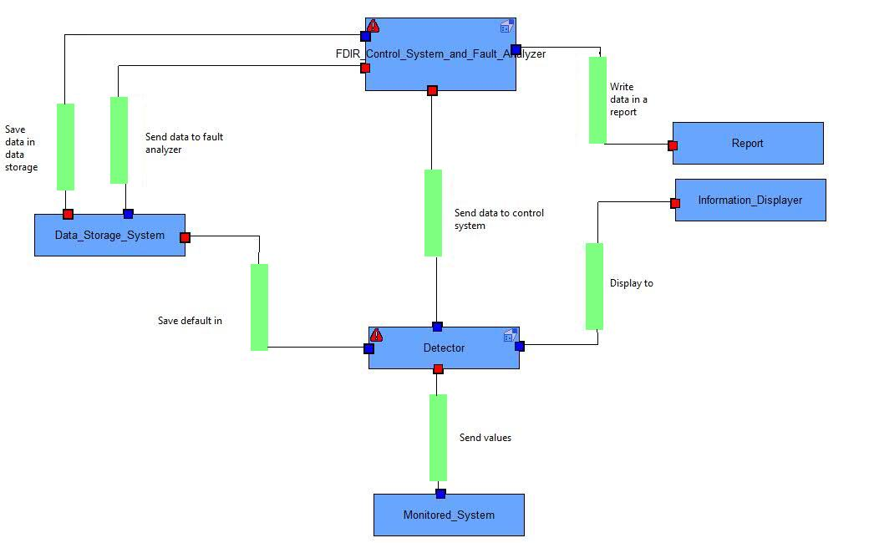

Here we can see the different components of the architectures we made before. So we have the monitored systems which send values to the detector. All the components are connected by using an event bus. This bus stored the information during the time the receiver component process the previous data. The detector is connected to almost all systems in order to analyze, store and display for the crew the problems that occurred. The control system and fault analyzer is connected to the data storage system in order to save and bring the data it needs, and writes them in a report.

But the top component is divided in two, the control system and the fault analyzer:

That’s a strength of ACMEStudio : we can represent a subsystem inside a component, in order to have a better understanding of the system.

The top component has a subsystem too:

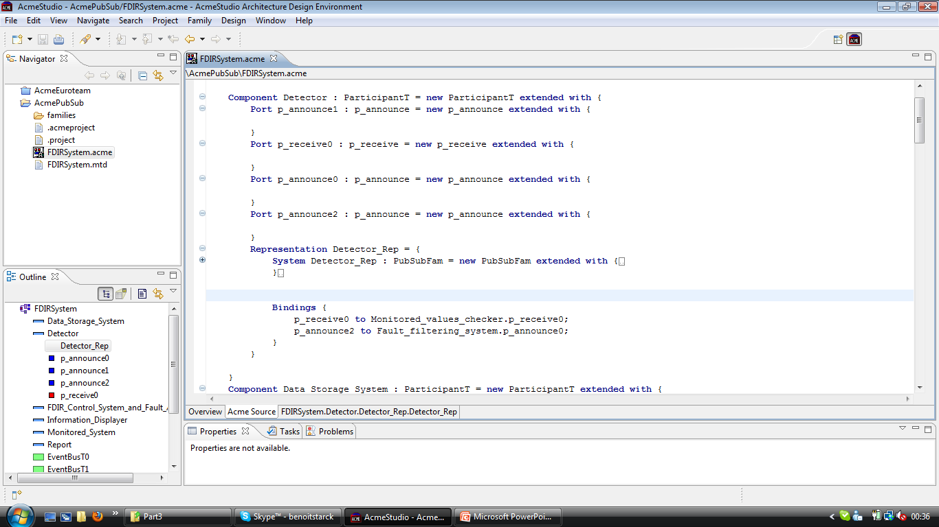

Here is a screen of the source code tab, which displays in real time the code corresponding to the architecture we draw.

1. **Architectural approach analysis**

Advantages

Loosely-coupled: Publishers are loosely coupled to subscribers, and needn't even know of their existence. With the topic being the focus, publishers and subscribers are allowed to remain ignorant of system topology. Each can continue to operate normally regardless of the other. In the traditional tightly-coupled client-server paradigm, the client cannot post messages to the server while the server process is not running, nor can the server receive messages unless the client is running. Many pub/sub systems decouple not only the locations of the publishers and subscribers, but also decouple them temporally. A common strategy used by middleware analysts with such pub/sub systems is to take down a publisher to allow the subscriber to work through the backlog (a form of bandwidth throttling).

Scalable: For relatively small installations, pub/sub provides the opportunity for better scalability than traditional client-server, through parallel operation, message caching, tree-based or network-based routing, etc. However, as systems scale up to become datacenters with thousands of servers sharing the pub/sub infrastructure, this benefit is often lost; in fact, scalability for pub/sub products under high load in large deployments is very much a research challenge.

The most serious problems with pub/sub systems are a side-effect of their main advantage: the decoupling of publisher from subscriber. The problem is that it can be hard to specify stronger properties that the application might need on an end-to-end basis:

* As a first example, many pub/sub systems will try to deliver messages for a little while, but then give up. If an application actually needs a stronger guarantee (such as: messages will always be delivered or, if delivery cannot be confirmed, the publisher will be informed), the pub/sub system probably won't have a way to provide that property.

* Another example arises when a publisher "assumes" that a subscriber is listening. Suppose that we use a pub/sub system to log problems in a factory: any application that senses an error publishes an appropriate message, and the messages are displayed on a console by the logger daemon, which subscribes to the errors "topic". If the logger happens to crash, publishers won't have any way to see this, and all the error messages will vanish.

As noted above, while pub/sub scales very well with small installations, a major difficulty is that the technology often scales poorly in larger ones. These manifest themselves as instabilities in throughput (load surges followed by long silence periods), slowdowns as more and more applications use the system (even if they are communicating on disjoint topics), and so-called IP broadcast storms, which can shut down a local area network by saturating it with overhead messages that choke out all normal traffic, even traffic unrelated to pub/sub.

For pub/sub systems that use brokers (servers), the agreement for a broker to send messages to a subscriber is in-band, and can be subject to security problems. Brokers might be fooled into sending notifications to the wrong client, amplifying denial of service requests against the client. Brokers themselves could be overloaded as they allocate resources to track created subscriptions.

Even with systems that do not rely on brokers, a subscriber might be able to receive data that it is not authorized to receive. An unauthorized publisher may be able to introduce incorrect or damaging messages into the pub/sub system. This is especially true with systems that broadcast or multicast their messages. Encryption (e.g. Transport Layer Security (SSL/TLS)) can be the only strong defense against unauthorized access.

1. **Discussions & alternatives**

**Conclusion**

The role of publish/subscribe systems is to permit the exchangeof events between producers andconsumers in an asynchronous manner.Thanks to the three dimensions decoupling (time, space, synchronization), participants (producers & consumers) can operate independently. None of the P/S is perfect. Scalability remains a big issue for P/S. Studying these solutions let us think that it could be better to try to merge and take the best parts of every P/S principle.

**References**

**Web Sites**

**Books**

1. [BCK98] L**. Bass, P. Clements, R. Kazman**, *Software Architecture in Practice (2nd ed.)*, Addison-Wesley, 2003.
2. [Eas98] **Steve Easterbrook, and et al**., “Experiences Using Lightweight Formal Methods for Requirements Modeling,” *IEEE Transactions on Software Engineering, Vol. 24, No. 1*, January 1998.
3. [KKC00] **R. Kazman, M. Klein, P. Clements**, *ATAM: A Method for Architecture Evaluation*, CMU/SEI-2000-TR-004, Software Engineering Institute, Carnegie Mellon University, 2000.
4. [SG96] **M. Shaw and D. Garlan**, *Software Architectures – Perspectives on an Emerging Discipline*, Prentice Hall, 1996.
5. **P. T. Eugster, P. A. Felber, R. Guerraoui and A. M. Kermarrec**, *The Many Faces of Publish/Subscribe*, in ACM Computing Surveys, vol. 35, no. 2, June 2003, pp. 114-131

**Annexes**